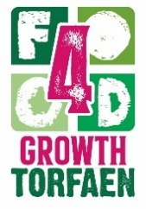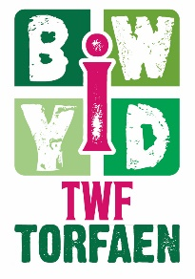
Torfaen Food Partnership
FOOD CHARTER
The Vision
Torfaen Food Partnership
FOOD CHARTER

To develop a sustainable and fair food system that provides affordable and healthy food for all.

Our Good Food Priorities
Our Health
Tackling food poverty and the health inequalities that result from it.
Increase accessibility and provide more opportunities to grow, cook and eat good food.
All food providers should be encouraged to provide safe, nutritious food to promote the health and wellbeing of the people they serve.

Our Community
Improve access to low cost healthy food.
Support services to build resilience to tackle poverty.
Support communities to have access to a range of resources that enables them to take more control of their food choices.

Our Jobs
Create a thriving food economy.
Improve employment opportunities.
Transforming catering and procurement and revitalising local supply chains.

Our Education
Educate a sustainable food culture.
Increase knowledge and skills in growing, cooking and nutritious eating.
Food Journey from source to waste.

Our Future
Reduce food waste, food miles and encourage a sustainable food culture.
Promote food systems that protect our environment.
Develop actions that impact climate change

OUR RESPONSIBILITIES

The Torfaen Food Partnership believe that everyone in Torfaen should have access to healthy, tasty and affordable food.

By promoting the Good Food Priorities, we will create healthy, sustainable and ethical food as part of a thriving local economy.

The Torfaen Food Charter will improve the health and wellbeing of residents and create a more vibrant, connected and resilient future.

For more information, please email the Torfaen Food Resilience Team @

Food4Growth@torfaen.gov.uk

