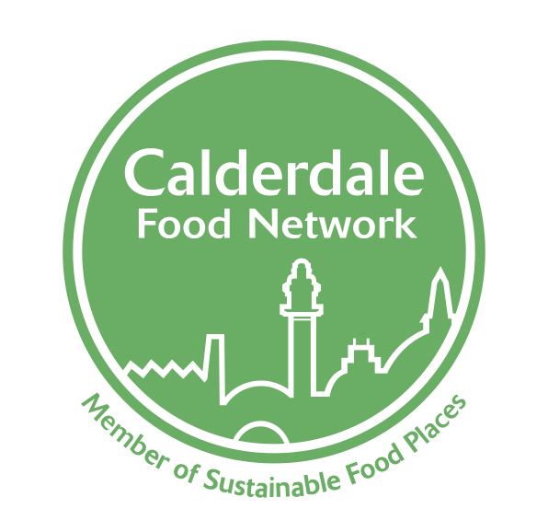
Calderdale Food Network

TERMS OF REFERENCE

- Vision and aims

Vision: To establish a culture where healthy, affordable, sustainable, local food is accessible to all.

The Calderdale Food Network aims to:
- Promote healthy and sustainable food to everyone in Calderdale.
- Tackle food poverty and ensure everyone has access to healthy and sustainable food.
- Improve the nutrition of the Calderdale population, a risk factor to ill-health.
- Build community food knowledge, skills, resources and projects.
- Promote a vibrant and diverse sustainable food economy.
- Support healthy and sustainable catering and food procurement.
- Reduce waste and the ecological footprint of the food system.

- Membership and engagement

The Calderdale Food Network is inclusive and open to all. Members of the Calderdale Food Network are drawn from public, private and third sector organisations that have an interest in creating a sustainable and equitable food system. The network seeks to be representative of the communities / organisations / businesses / activists working within the food landscape in Calderdale. Members include individuals, groups and organisations interested in healthy and sustainable food in our borough.

The Network will enable three types of engagement:

Network Members:
Any person, group or organisation can become a member of the Network by contacting the Coordinator or a member of the Steering Group. Food Network Members:
- Support the vision and aims of the Network
- Receive and share regular updates about the Network and its activity, as well as broader news, events and opportunities associated with sustainable food
- Have the opportunity to input into Food Network developments and action plans

Action Group Members:
Network Members may engage in specific action groups related to the work of the Food Network. Action groups will identify a person who will be a contact for the Network and Steering Group.

Steering Group Members:
Members can be part of the Steering Group. This involves:
- working proactively to achieve the vision, aims and actions of the Network
- development, delivery and monitoring of an agreed Action Plan
- raising awareness, understanding and developing support for the Network and its work including supporting internal and external communication

Members of the Steering Group will be elected/agreed on an annual basis. The Steering Group are able to collectively agree the appointment of new Steering Group members where there are gaps, or the group requires expertise in a particular area. The number of representatives on the Steering Group will be a minimum of 5 and will not exceed 20 people/groups/organisations.

- Chair of the Calderdale Food Network Steering Group

The role of Chair will be held by the coordinator.

- Public Engagement

The Calderdale Food Network will engage the wider public through:
- Campaigns
- A brand and logo
- An annual general meeting / public engagement event
- Visibility of the Calderdale Food Network at local food festivals and events
- A Calderdale Food Network charter than anyone can sign up to support
- An on-line platform

- Calderdale Food Network Meeting arrangements

There will be at least four Calderdale Food Network Steering Group Meetings a year. Steering Group Members will attend each meeting if possible. Any member of the Calderdale Food Network can attend meetings; however, venue capacity may limit the attendance of more than 25 people. Meetings of the Calderdale Food Network will be arranged as follows:

- meetings will take place approximately monthly and dates will be confirmed 3 months in advance
- the quorum for voting at meetings will be 50% of the Steering Group Members
- Steering Group Members who have not attended four consecutive meetings will be assumed to have resigned from the Steering Group, unless, on the basis of information, the group decides otherwise.
- a member of the Steering Group must identify any areas of personal or pecuniary interest before discussion on that item and if deemed necessary will leave the room for discussion on that item.

- Accountability

The Calderdale Food Network connects with the following groups and is responsible for sharing meeting notes and consulting with these groups as appropriate:

- Calderdale Metropolitan Borough Council (CMBC)
- Voluntary Sector Infrastructure Alliance (VSI)
- Voluntary and Community (VAC)
- Halifax Opportunities Trust (HOT)
- Calderdale and Huddersfield NHS Foundation Trust (CHFT)
- Food for Life (FFL)
- Food Poverty Forum
- Calder Veg Collective

