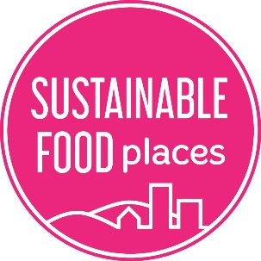
SFP Membership application

Please complete the following information and email this form, along with all supporting documents, to info@sustainablefoodplaces.org by the application deadline. You can find deadlines, and information about membership criteria, at www.sustainablefoodplaces.org/get_involved/become_a_member/.

Partnership information
Name of your food partnership
Name of your food partnership’s host organisation (if applicable)
Name and contact details of the person completing this application
The named lead person for your food partnership (if different to above)

Place information
Please describe the geographic area that your food partnership represents and which local authority/authorities this area relates to. (150 words max).

Supporting documents
For each of the membership criteria below, please provide us with a document that evidences how your partnership meets the criteria. Please provide the file name below and attach all files to your email to us along with this form.
Membership criteria | Name of file/s
Terms of reference, including a list of stakeholders and an outline of your vision
Meeting minutes to evidence that the partnership has been actively meeting for at least 6 months (at least 6 meetings).
Food Partnership Work Plan covering next 6 months.
Food System Overview covering existing food system action / assets

