|  |
| --- |
| **Sustainable Food Places** |
| **SFP Awards: Guidance for Applicants 2025** |
| **The process of applying for an SFP award** |

**SFP Awards: Guidance for applicants 2025**

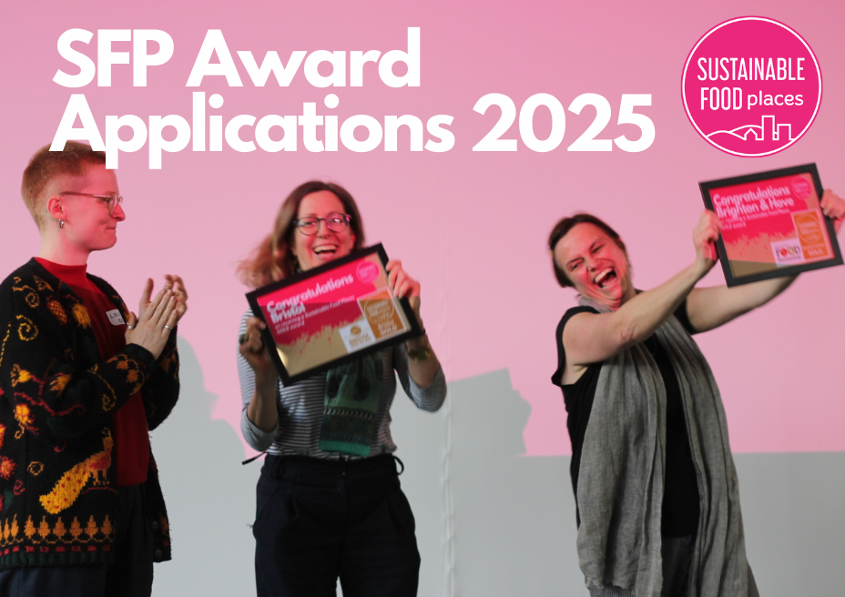**This document outlines the process of applying for an SFP Award.**

**Please read this, along with the following documents, before starting an application:**

* SFP Awards: Activity and impact: [SFP Awards - Activity and Impact.docx](https://docs.google.com/document/d/14DqzfuoYmJJMcynigPkyRM3PCh_Wp3fz/edit?usp=share_link&ouid=103829846257470209960&rtpof=true&sd=true)
* SFP Awards Application Form

**Contents**

**SECTION 1: Introduction** 2

**Why apply for an award?** 2

**SECTION 2: What do we need to do to achieve Bronze or Silver?** 3

**Bronze and Silver** 4

**Gold** 6

**SECTION 3: Before starting an award application** 8

**SECTION 4: Process and timeline for 2025 Awards round** 9

**SECTION 5: Our SFP Awards agreement** 10

**SECTION 6: Using the application form** 11

Word limits 12

Additional documents and links 12

**SECTION 7: Submitting your application** 12

**SECTION 8: How your application will be assessed** 12

Further information 13

# **SECTION 1: Introduction**

The Sustainable Food Places Awards are designed to recognise and celebrate the success of places in the UK taking a joined up, holistic approach to sustainable and healthy food. Awards are open to any place which is a [member](https://www.sustainablefoodplaces.org/members/) of the Sustainable Food Places Network. The Bronze, Silver and Gold awards represent progressive levels of achievement across the local food system, and the awards programme is designed to support places to achieve award progression over time.

The SFP Awards framework assesses activity and impact across 6 key food issues, each containing two action areas (see the application form for full details). To achieve any SFP award, places must demonstrate action and impact in all key issues and action areas within the past 3 years. The activity represented by an application does not all have to be delivered by the food partnership itself – it can include work done by anyone in the place. However, we believe that the presence of a strong partnership is likely to make this work more wide-ranging, better joined up and more impactful. For this reason, Governance and Strategy is our first key issue under our framework.

## **Why apply for an award?**

The decision to apply for an SFP award should be taken collectively by a local food partnership. Based on the experience of past awardees, we believe that working towards and applying for an SFP award can support a local food partnership to:

* Map activity and impact across areas of local food work.
* Provide momentum for local collaboration and your local good food movement.
* Recognise the work of all local stakeholders, including those yet to connect to your partnership.

Achieving an SFP award can:

* Provide national recognition of your local food work.
* Help you gain support from local institutions and funders.
* Create a moment for local public engagement and support.

**SFP Awards eligibility criteria:**

* Your place is a current [member](https://www.sustainablefoodplaces.org/members/) of the SFP network.
* For Bronze a current 1 year action plan is required
* For Silver a current 3 year action plan is required

Advice on SFP awards and funding

SFP strongly recommends that applying for and/or achieving an SFP Award does not form a condition of funding or any other form of institutional support for a food partnership. Food systems change work is complex and can be impacted by a range of factors beyond the control of a partnership. Funding conditions attached to SFP awards can create unhelpful pressures on a partnership and those in a coordination role. We recommend that a partnership takes a collective decision of when to apply for an award.

# **SECTION 2: What do we need to do to achieve Bronze or Silver?**

The SFP Awards recognise progressive levels of achievement across all 6 of SFP’s Key Issues:

Each key issue has 2 action areas (A and B). Please refer to *SFP Awards: activity and impact* [SFP Awards - Activity and Impact.docx](https://docs.google.com/document/d/14DqzfuoYmJJMcynigPkyRM3PCh_Wp3fz/edit?usp=share_link&ouid=103829846257470209960&rtpof=true&sd=true) for action areas (A and B) under each key issue, SFP’s rationale for including these key issues, and illustrative examples of actions for each key issue.

For some action areas there are specific **mandatory** actions needed to achieve Bronze or Silver. These are outlined in *SFP Awards: activity and impact.* [SFP Awards - Activity and Impact.docx](https://docs.google.com/document/d/14DqzfuoYmJJMcynigPkyRM3PCh_Wp3fz/edit?usp=share_link&ouid=103829846257470209960&rtpof=true&sd=true)Beyond the mandatory actions, we will consider a wide range of activity that reflects the specific challenges and opportunities in your place. Failure to submit the correct evidence under mandatory criteria will mean your application will be rejected at the eligibility stage.

To help guide your application and assess your readiness, the information below broadly describes what SFP expects to see in place to achieve each award level. Please note that you must read *SFP Awards: Activity and Impact* [SFP Awards - Activity and Impact.docx](https://docs.google.com/document/d/14DqzfuoYmJJMcynigPkyRM3PCh_Wp3fz/edit?usp=share_link&ouid=103829846257470209960&rtpof=true&sd=true) for full information on mandatory and example actions at each award level.

### **Bronze and Silver**

**

SFP Bronze, Silver and Gold awards celebrate progressive levels of achievement across all SFP’s six key issues. In summary, our award progression can be understood as:

**Bronze:** A cross-sector food partnership is in place, with activity and impact delivered across all six key issues. A wide range of initiatives, policies and strategies are supporting access to healthy and sustainable food, with evidence of an emerging and diverse good food movement. There is recognition of, and institutional support for, sustainable food enterprises.

**Silver:** A diverse, robust, and sustainable cross-sector food partnership is in place, and a long-term food strategy (or plan), along with a range of local authority policies and food access initiatives, are effectively promoting access to sustainable and healthy food for all. There is a diverse and connected local good food movement. Sustainable food enterprises have a significant role in your local economy, backed by local catering and procurement practices. Systemic responses are addressing the negative climate and nature impacts of the local food system.

Benchmarking

To recognise and celebrate the diversity of places and local good food movements across the UK, SFP takes a flexible approach to what combination of activity and impact is needed to achieve an award. Whilst the panel will refer to the work of previous successful award applications in considering the benchmark, the panel will also consider each applicant place’s unique achievements and its political, social, and economic context. We highly recommend that you read last year’s successful applications on our website ([Current Sustainable Food Places Award Winners | Sustainable Food Places](https://www.sustainablefoodplaces.org/awards/awardwinners/)) to help inform whether you are ready to apply, and to provide inspiration for action.

**More details on bronze and silver award benchmarking**

***mandatory criteria underlined***

|  |  |  |
| --- | --- | --- |
| **Key Issue** | **Bronze** | **Silver** |
| **1: Taking a strategic and collaborative approach to good food governance and action** | A cross sector partnership is in place  A current 12-month action plan covering actions on all key issues  Some evidence of recognition of healthy and sustainable food in local policies, strategies, and plans | Your partnership is diverse, robust, embedded, and sustainable  A current 3-year strategy and/or action plan covering all key issues that is endorsed and supported by the local authority  Evidence that policies, strategies, and plans are effectively promoting healthy and sustainable food |
| **2: Building public awareness, active food citizenship and a local good food movement** | A range of well promoted public events and engagement opportunities and the beginnings of a local food network. | Widespread public participation in food-related community activity, underpinned by a connected network of community food initiatives which support a dynamic good food movement, involving people from all walks of life. |
| **3: Tackling food poverty and diet related ill-health and increasing access to affordable healthy food** | A wide range of initiatives that are working to tackle food poverty and diet-related ill health. | A wide range of initiatives working to tackle food poverty and diet-related ill health are reaching most social groups, settings, and neighbourhoods, particularly amongst those groups most at risk, and demonstrating positive impact. |
| **4: Creating a vibrant, prosperous, and diverse sustainable food economy** | The local authority and other key bodies recognise the role and importance of sustainable food enterprises and are actively working to support their development and success. | Sustainable food enterprises have become a significant part of your local food economy and are positively reshaping the high street and wider food environment. |
| **5: Transforming catering and procurement and revitalising local and sustainable food supply chains** | Examples of sustainable food procurement policy and accredited practice in a range of institutions | Healthy and sustainable food catering is becoming the norm across a full range of institutions, supported by strong local authority leadership.  Evidence that significant levels of procurement by a range of institutions are benefitting local, sustainable, independent, and smaller-scale producers and other food businesses. |
| **6: Tackling the climate and nature emergency through sustainable food & farming and an end to food waste** | Action on promoting and supporting sustainable food production and consumption, improving resource efficiency throughout the food chain, and tackling food and food-related waste. | Effective strategic and systemic responses, including by the local authority, to address the negative climate and nature impacts of the local food system. |

# **SECTION 3: Before starting an award application**

**Stop and read**

The decision to apply for an award should be taken and actively supported by your partnership, rather than just your coordinator or host organisation; the process of gathering evidence requires the support of many stakeholders, and awards reflect the work of whole communities. We recommend that partnerships put the appropriate support in place for the individual(s) who are leading on the application.

* **Fully read these documents:** 
  + S*FP Awards: activity and impact* [SFP Awards - Activity and Impact.docx](https://docs.google.com/document/d/14DqzfuoYmJJMcynigPkyRM3PCh_Wp3fz/edit?usp=share_link&ouid=103829846257470209960&rtpof=true&sd=true)
  + *SFP Awards Application form* [SFP Awards - Application Form.docx](https://docs.google.com/document/d/1MBi5L1rd9VDe2IXCwnGUb7b7FDitPp9s/edit?usp=share_link&ouid=103829846257470209960&rtpof=true&sd=true)

To build evidence of local activity and impact, and assess whether you feel ready to apply for an award, you will need the input of a wide range of stakeholders. You may want to run participative processes and events to record the range of food activity and impact in your place. We recommend using various tools in the SFP Food Partnership and Strategy Toolkit, including our Food System Mapping guide ([Food_System_Mapping.pdf (sustainablefoodplaces.org)](https://www.sustainablefoodplaces.org/resources/files/SFP_Toolkit/Food_System_Mapping.pdf)), to help you do this.

# **SECTION 4: Process and timeline for 2025 Awards round**

**The following is our awards timeline for bronze and silver awards.** Gold award timelines can be discussed with the SFP Team ([info@sustainablefoodplaces.org](mailto:info@sustainablefoodplaces.org)).

* **Expressions of Interest:** Opened 19th Marcg and 18th April 2025
* **Monday 9th June:** Awards application and guidance documents released.
* **Monday 9th June:** Application opens – you can submit from this date until 6th October 2025
* **Tuesday 15th July 11:00 – 12:15:** Guidance sessions for awards applicants. All applicants are invited attend this online webinar where the SFP programme team will share guidance on applying for awards and there will be an opportunity for questions. These sessions will be recorded. There is strong evidence that applicants who joined or watched back these sessions scored more highly at the assessment stage. Invitations will be sent out directly to applicants.
* **Monday 6th October, 5pm**: Final submission deadline
* **W/C 27th October:** Outcome & feedback communicated to all applicants

# **SECTION 5: Our SFP Awards agreement**

Participation in the SFP Awards programme is based on a shared understanding between the award applicant and the SFP programme about what is required by both parties. By submitting an expression of interest and/or applying for an award, you are signing up to the following agreement.

The **SFP Programme and awards panel** will:

* Deliver an equitable and transparent application process for all applicants
* To the best of their ability, assess your application based on the information and evidence provided in your application along with professional knowledge about local food systems work and your specific geographic, political, and social context.
* Offer drop in sessions (1 for Bronze, 1 for Silver) to discuss the application process
* If you are unsuccessful, provide limited feedback on your application’s areas of relative weakness.

**As an SFP Award applicant**, your partnership (or representative/s of it) will:

* Fully read this document, along with *SFP Awards: Activity and Impact* and *SFP Awards application form* before starting your application.
* Endeavour to provide information and evidence in an accessible way that supports the process.
* Ensure to attend online support sessions or ask a local partnership colleague to attend.
* Submit your application by the given deadlines.
* Allow the SFP programme to publish successful applications on our website. We may also use information in your application for communication and evaluation purposes.

**Please also note that:**

* The awards panel’s decision is based on their collective, subjective opinion informed by a systematic assessment of your application that includes double (and triple) reading if necessary.
* To ensure we offer a consistent approach to all applicants, the SFP Programme Team will be unable to provide detailed 1:1 support (including reviewing draft applications) during the process, but will provide drop-in sessions to discuss the application process, and encourage peer support with previous award winners.
* The awards panel reserves the right to uphold its decision.
* If the opportunity arises, the SFP Programme staff may advise you that your place is not ready to apply for an SFP Award. **However, accepting your application is no guarantee that you will be successful in achieving your award.**
* The SFP Programme and awards panel does not accept responsibility for any impact on your partnership or organisation’s reputation or resourcing if your award application is not successful.

# **SECTION 6: Using the application form**

Please use SFP Awards application form to complete a **bronze or silver** award application.

The application form provides the opportunity for you to evidence the activity and impact that has happened in relation to the SFP key issues and action areas within the last 3 years.

**Section 1: (not scored)**

In Section 1 of the form, you can provide the panel with background information about your place, including (but not limited to) demographic, geographic and political information. This will help the panel consider the context in which your work is happening.

We have also asked you to consider how diverse and inclusive your work is at a local level. Good food governance means diverse, representative and inclusive partnerships, and we are keen to see the steps you have taken to ensure your partnerships best represent the diversity of your place.

**Section 2:**

For each key issue, you will be asked to detail any evidence relating to relevant activity and impact under each action area (A and B for each key issue).

For each section, please describe the activity and impact. For each Key Issue, section C provides the opportunity to describe activity and impact that does not fit in to actions areas A and B. You may also use this section to give information about your place that may have shaped or limited your impact in this area. You will not be penalised for leaving section C blank.

When completing sections, A, B and C for each key issue, please provide the following where possible and relevant:

* Beneficiary numbers (and other details of beneficiaries).
* Specific named policies, strategies, and plans, providing links to webpages or online documents.
* Specific named partners, organisations, and initiatives.
* References (links where possible) to quoted or relevant research.
* Where your partnership has had influence. This is essential at Silver.

## Word limits

The application provides advisory word limits, or mandatory where stated. For advisory limits, you will not be penalised for exceeding them. This is designed to help you manage the time needed to complete the application and allow you to evidence extensive work and impact where relevant. However, we strongly request and advise you to stay within a reasonable range of the limit to help the Awards Panel navigate your application, focus on key information, and give equitable focus to each application.

## Additional documents and links

Only submit additional documents for food action plans and strategies related to Key Issue 1 mandatory criteria. These documents may also be evidenced by links. All other additional documents will not be assessed. You may add links to online documents but always check the links and permissions as we will not be requesting changes from you after submission

You may wish to provide **links** to videos, news articles, photos, or other illustrative materials. **Please ensure that core and essential information is written on the form as the Awards panel cannot guarantee to look at all extra resources and information in detail.** Please be judicious with the number of links you supply and check that they are all working.

# **SECTION 7: Submitting your application**

All completed application forms must be sent to [info@sustainablefoodplaces.org](mailto:info@sustainablefoodplaces.org) by 5pm on 6th October 2025.

Please submit your application in the original Word format.

* Do not convert to PDF
* Do not alter the layout or design of the application document as it will be rejected at the eligibility stage

# **SECTION 8: How your application will be assessed**

Your application will be assessed by an awards panel made up of staff members from the SFP Programme’s delivery organisations. The panel will be supported and advised by staff from the SFP programme team and partners with expertise in the national and geographic contexts you are working in.

The panel will assess your application by systematically considering your activity and impact under each key issue and action area, whilst also looking at your application holistically. All action and impact will be considered in relation to the political, economic, geographic, and national contexts in which you are working. Where appropriate, the panel and staff advising them will refer to previous successful applications to inform their discussion.

To reflect the complex and flexible nature of the SFP Awards, your application will not be numerically scored. Instead, the panel will use the following Green, Amber, Red system to qualitatively assess areas of relative strength and weakness. Each action area under each key issue will be categorised as Green, Amber or Red as follows:A picture containing text, screenshot, font, design

Each application is to strive for full green, but a successful application can still be awarded with 2 amber ‘Key Issues’.

A red score will result in feedback provided for the next round of awards. More than 2 red scores means the application has failed to meet that award level. A red score for a mandatory criteria is an automatic fail.

Outcomes are based on double reading and scoring then the consensus view of the panel, based on a subjective yet systemic and informed understanding of your application. The panel endeavours to arrive at this decision with rigour and fairness. The panel reserves the right to uphold its decision.

If your application is unsuccessful, the panel will provide specific feedback on areas of relative weakness, along with suggestions of action to implement in time for future awards rounds.

### Further information

If you have any further questions about the awards programme after reading this document, please contact the SFP team at [info@sustainablefoodplaces.org](mailto:info@sustainablefoodplaces.org).