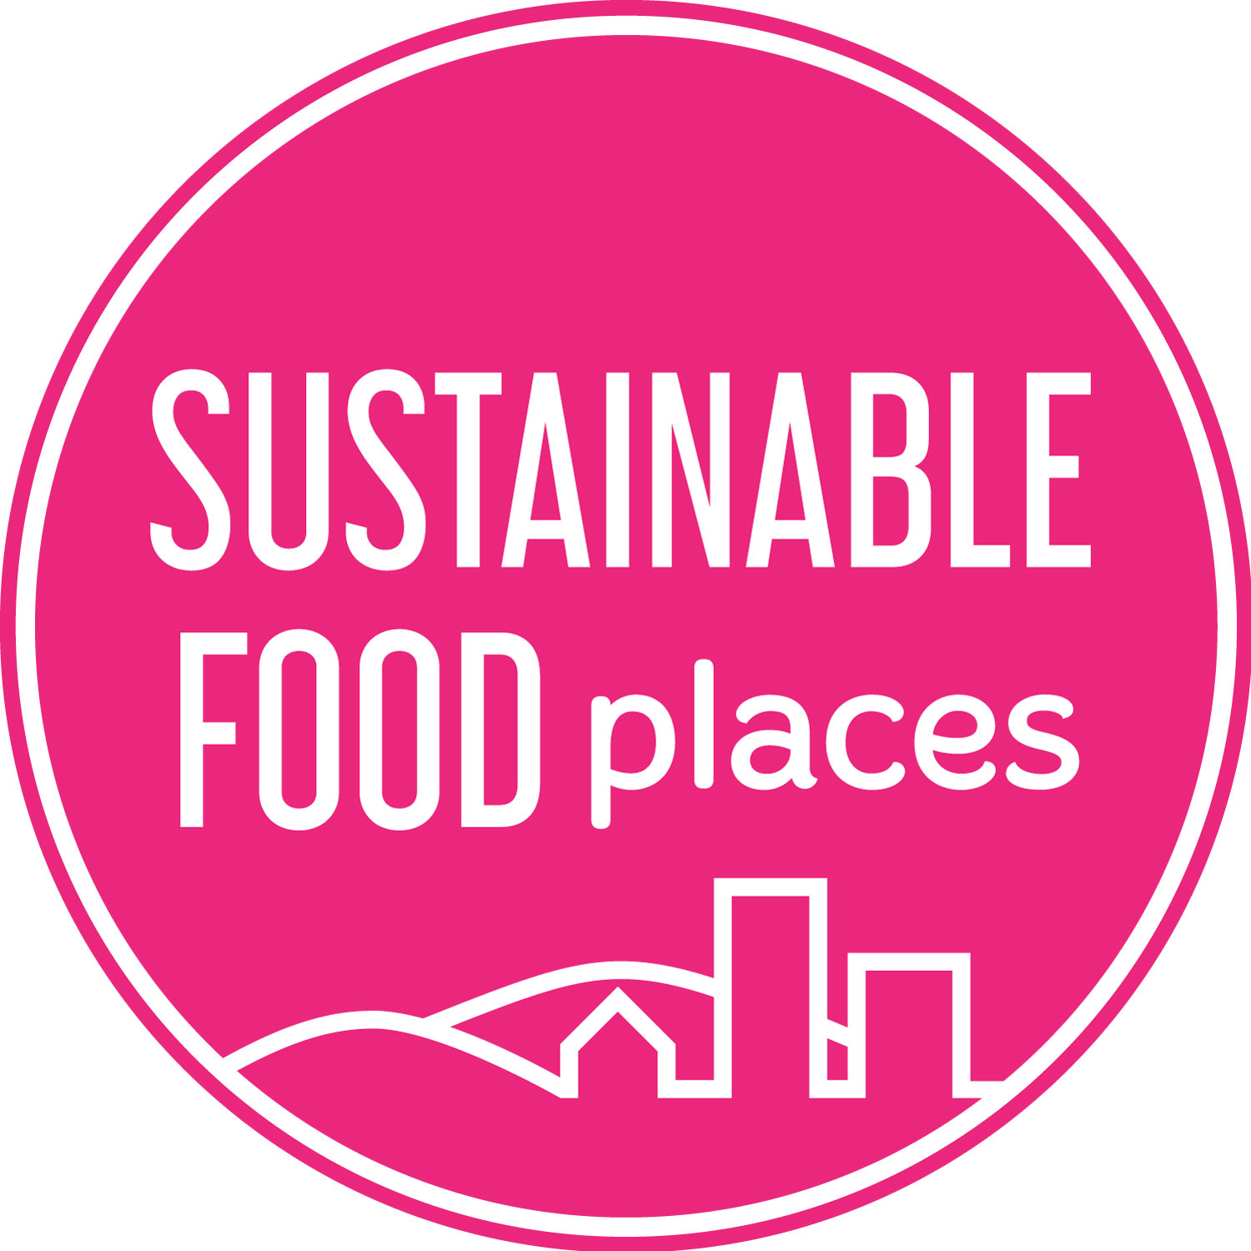

SUSTAINABLE FOOD PLACES PHASE 3
Expression of interest for Good Food Movement Pilot Grant
June 2020

Background
Sustainable Food Places (SFP) is embarking on Phase 3 of its programme. One of the key strands in Phase 3 is about helping partnerships to nurture, support and sustain local good food movements, reaching out to new audiences and enabling them to connect, communicate and collaborate as active food citizens as they work together to transform their local food system.
Our longer-term aim is to provide Network members with a range of tried and tested methods for effectively building individual, community and institutional engagement in food action and maintaining the connections between them as part of a dynamic local good food movement. By providing grant funding and bespoke support, we can then help member partnerships to adapt and adopt the methods that work best for them.
The first step to achieving this will be a test and learn phase, with a small round of grants for pilot initiatives, trying out approaches and gathering learning before opening the grant and support opportunity out to the wider SFP Network in 2021. In practice, this might involve:
- Developing a city-wide public facing campaign to educate individuals and institutions about good food and inspire them to take specific action.
- Creating physical and on-line spaces and opportunities for both those already involved and those interested in positive food action to communicate and collaborate.
- Providing opportunities for new audiences and new communities to get practically involved in community food projects, campaigns and other initiatives.
- Creating opportunities to bring people together through food, building new relationships and social connections and fostering a sense of common purpose.
We are interested in any and every idea that can help bring people together to play an active, ongoing role in their local community and their local food system that contributes and is connected to the work of your local food partnership. Key for us, at this test and learn stage, is that we support a good range of initiatives that clearly contribute to creating, connecting and sustaining a local good food movement and that could, with adaptation, be adopted by other SFP partnerships.
We are therefore calling for expressions of interest from members that are interested in working with the SFP national team to develop and test initiatives they feel can really drive a step change in sustained local participation in good food action.

Grant offer
Good Food Movement Grant: We are offering up to 6 grants of £5,000 each to be spent within 12 months. If you can show match funding or in-kind contributions to support your proposed initiative it will add to the strength of your application, but this is not a requirement.
To manage down the time and effort of prospective applicants, we are only asking for expressions of interest at this stage. We will then invite those with ideas that seem most relevant and most replicable to submit a more detailed application before making a final decision on which to fund.

How we will deal with your expression of interest
Email your completed expression of interest form to vera@sustainweb.org
You will receive an email from us confirming that we have received your expression of interest. Expressions of interest are assessed by the SFP Programme Management Board and all decisions are final. We may ask you for further information. We aim to deal with all applications in a friendly and efficient fashion. If we fall short of these aims, please let us know. We can provide limited feedback upon request to unsuccessful applicants.

Timeline
Thursday 18th June 2020 Applications open
9am Thursday 2nd July 2020 Deadline for Expression of Interest applications
Thursday 9th July 2020 Grants Panel decision which pilots invited to full application
w/c Monday 13th July 2020 Invitation to short-listed applicants to submit a full application. Communication to unsuccessful applicants
Early August 2020 Full application deadline
Mid August 2020 Communication to successful & unsuccessful applicants

Contact & eligibility
Partnership details
Name of local food partnership
Name of person writing this bid
Email
Phone Number
Eligibility
Sustainable Food Places member | Yes / No

Expression of interest
In the box below, please describe in no more than 500 words what you would like to do to build, extend and/or sustain public and/or institutional engagement and action around food as part of the creation of a more dynamic and inclusive local good food movement.
Where relevant, please show how this would build on work you have done to date or on existing assets and initiatives. Please also show how your proposal will:
- help to sustain good food action, connection and collaboration over the longer term; and
- how it has the potential to be adapted by other food partnerships in the SFP Network.

_________________________________________________________________________
Sustainable Food Places is a partnership programme led by the Soil Association, Food Matters and Sustain. It is funded by The National Lottery Community Fund and the Esmée Fairbairn Foundation.
