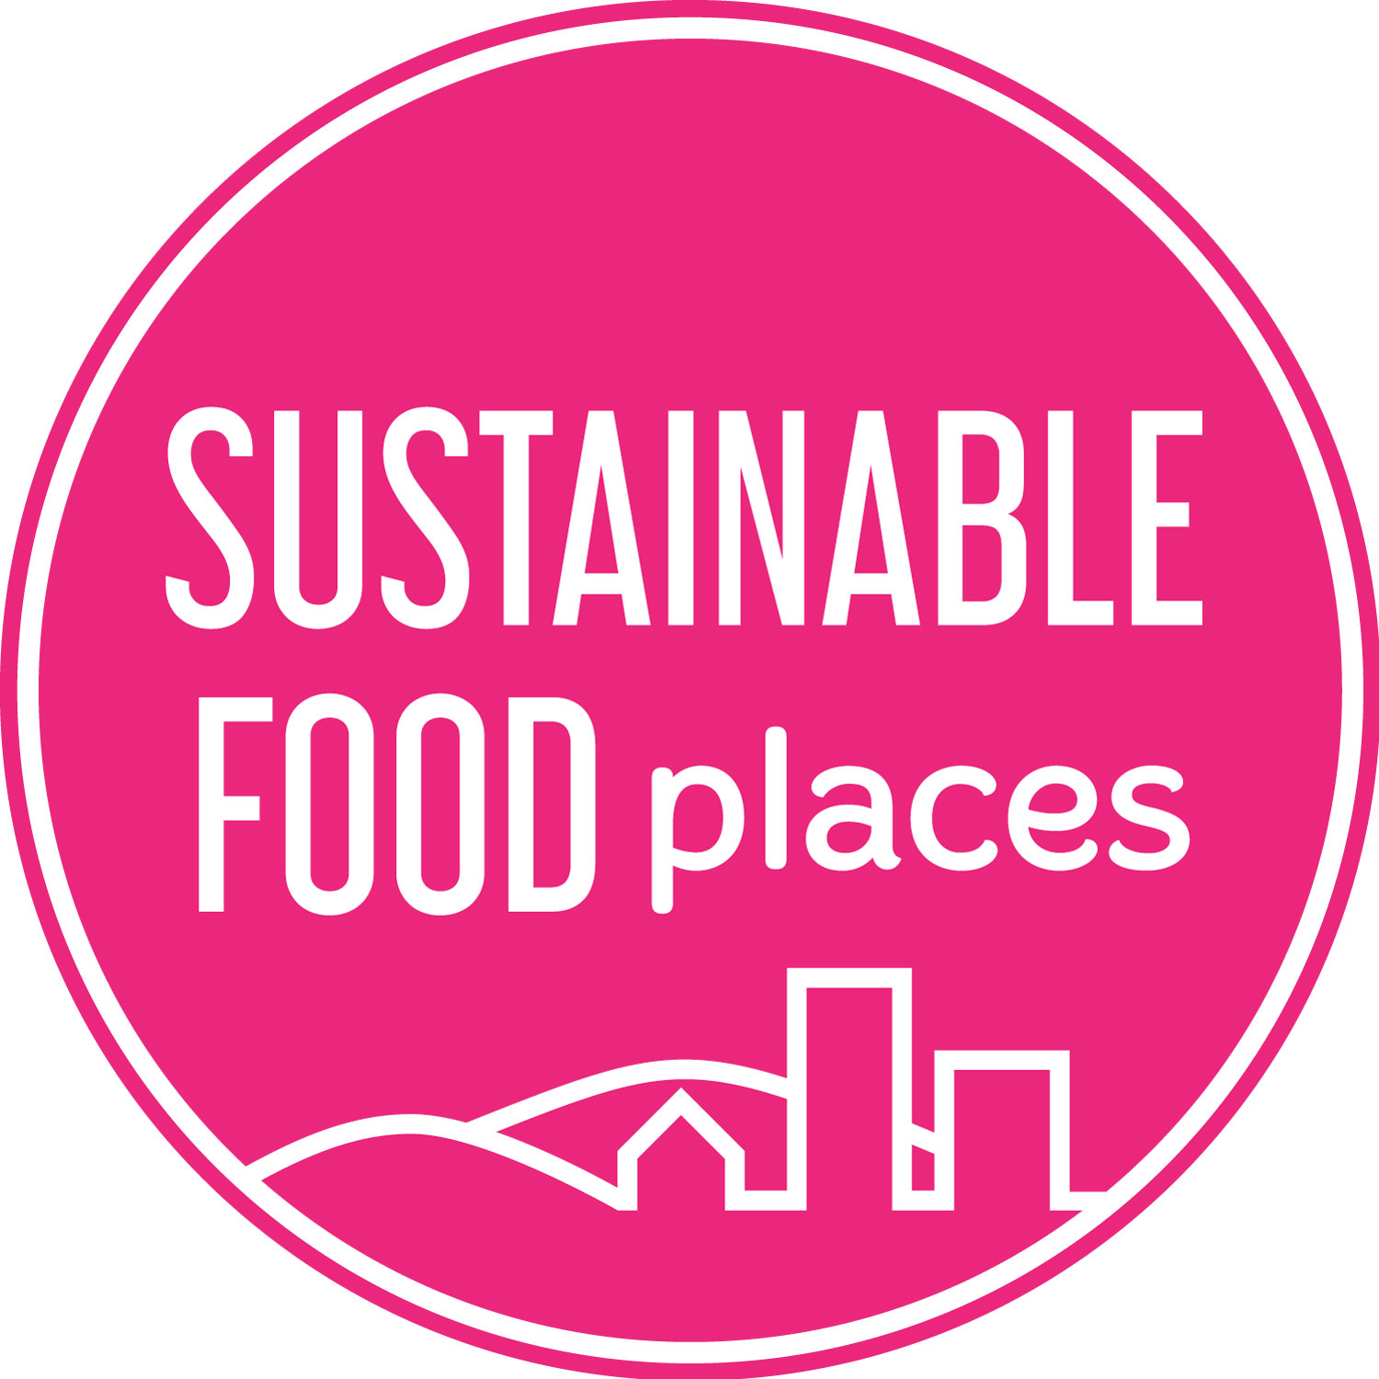

SUSTAINABLE FOOD PLACES PHASE 3
Grant Application
Emergency Support Grants
June 2020
Contents
1 Grants Application Guidelines 3
1.1 Background 3
1.2 Grant offer 3
1.3 Who can apply? 3
1.4 Terms, conditions and reporting 4
1.5 Grant submissions and work commencement 4
1.6 How we will deal with your application 4
1.7 Timeline 4
2 Grant Eligibility 5
3 Grant Application 6

Section 1: Grants Application Guidelines

Background
We have become increasingly aware that some Sustainable Food Places partnerships have become vulnerable during the Covid-19 pandemic as resources and attention have rightly been diverted towards vital emergency response work and as funding and support for wider food work have become more uncertain. Sustainable Food Places is therefore offering Emergency Support Grants of up to £5,000 each to eligible food partnerships to maintain their capacity and momentum through the Covid-19 crisis so that they can sustain their partnerships and programmes through these challenging times.
We are offering a small number of grants to partnerships that fit the following eligibility criteria. The grants are for currently active partnerships and must contribute towards existing coordinator capacity where that capacity is at risk over the next 6 to 12 months. They are only available to partnerships where coordinators are not employed by a local authority and that have not had the opportunity to apply for other Phase 3 coordinator grants to date. Priority will be given to partnerships where their future is at risk due to a lack of sufficient coordinator capacity.

Grant offer
We are offering a small number of grants of £5,000 each. The grant must be spent within 1 year of receiving funds.
Grants will contribute to the cost of existing coordinator capacity. They are intended to support ongoing core activities and maintaining the food partnership’s capacity, profile and network during the Covid-19 crisis and its immediate aftermath. The grant is not available to fund new posts or to coordinate significant new projects. The grant is not eligible to partnerships where the coordinator is a local authority employee.
To secure a grant you will need to demonstrate that your food partnership is currently active but vulnerable due to your coordinator capacity being at risk and that you have plans for future delivery.
You are not required to secure match-funding for this grant.
Successful applicants will be able to invoice for the first 80% of their grant shortly after confirmation in the week commencing 13th July 2020. You will be required to submit a report on the work you have undertaken with the grant for us to release the remaining 20%.

Who can apply?
This grant application is open to Sustainable Food Places members that:
- Have been active in the last six months. This must include core partnership activities but can include Covid-19 response delivery.
- Have existing coordinator capacity (paid or voluntary).
- Do not have a coordinator employed by a local authority.
- Are not currently funded by, have previously applied for, or have had the opportunity to apply for, an SFP Phase 3 Bronze to Silver Coordinator Grant or Silver to Gold Coordinator Grant.
- Are immediately vulnerable with regards to coordinator capacity and require this grant in order to continue their work for the coming 6 to 12 months.
In Sections 2 and 3 we ask you to provide more details relating to the above criteria. Please note that after we receive your application we may be in touch to ask you for clarification or further details.
If your partnership does not have a bank account, you must apply jointly with an organisation with a bank account that is able and ready to receive funds and manage finances appropriately.
Receipt of this grant will not restrict your eligibility for other SFP funding opportunities in the future.

Terms, conditions & reporting
If your partnership is awarded a grant, the Grant Offer Letter will detail the full terms and conditions we agree with you. This will include a requirement to complete a grant report.

Grant submissions and work commencement
You must submit your application by email, using the form and guidance below, by 9am on Thursday 2nd July. There will only be one round of applications for this grant. Applicants will be informed of decisions in the week commencing Monday 13th July. Successful applicant organisations will be able to invoice for 80% of the grant shortly after grants are confirmed. The grant must be spent within 1 year of receiving funds. You will be required to submit a report on the work you have undertaken with the grant for us to release the remaining 20%.
Use the form below to apply for a grant. Fill in the relevant sections and return this document to us by email. Please keep to the word limit for each question and do not submit additional materials.
Email your application to sfcgrants@soilassociation.org by 9am on Thursday 2nd July. Please specify in the subject line the name of your partnership.

How we will deal with your application
You will receive an email from us confirming that we have received your application. Applications are assessed by the Sustainable Food Places Grants Panel and all decisions are final. We may ask you for further information. We aim to deal with all applications in a friendly and efficient fashion. If we fall short of these aims, please let us now. We will provide limited feedback to unsuccessful applicants.

Timeline
Thursday 18th June 2020 Applications open
9am Thursday 2nd July 2020 Deadline for applications
Thursday 9th July 2020 Final decision by SFC Grants Panel
w/c Monday 13th July 2020 Communication to successful & unsuccessful applicants

Contact and Eligibility Form
All applicants must fill in this section
Partnership details
Name of local food partnership
Name of person writing this bid
Email
Phone Number
Eligibility
Is your food partnership a Sustainable Food Places member? | Yes / No
Has your food partnership previously had the opportunity to apply for or received an SFP Bronze to Silver Coordinator or Silver to Gold Coordinator Grant? | Yes / No
Does your partnership currently have coordinator capacity (paid or voluntary)? If so:  - Are they paid or a volunteer?  - How many days per month do they work? | Yes / No  Paid / Volunteer  ______days per month
Is the current coordinator a local authority employee? | Yes / No
Employing organisation
Please provide the following information about your employing/host organisation. This may also be your partnership if it is constituted
Name of organisation
Contact name
Contact email
Contact phone number
Organisation’s legal status
Who will provide line management?

Grant Application Form for SFC Coordinator
Please answer the following questions, staying within the given word limits.
Q1 Please provide us with a brief overview of your partnership’s activities over the last 6 months.
Maximum 250 words.

Q2 What is your partnership’s current financial & coordinator capacity situation? Based on current resources are you able to maintain coordinator capacity for the next 6 to 12 months?
Maximum 150 words.

Q3 What work is your partnership hoping to deliver over the coming year? For this grant, this should include core coordination activity such as convening stakeholders together, sub-group activity, communications to members, coordination and networking. It can also include Covid-19 response work and working towards an SFP Bronze Award.
Maximum 250 words

Q4 If you receive this grant:
- When would the funded coordinator work be delivered? Please provide approximate start and finish dates.

- How many days per week would your coordinator work for? Please provide approximate days per week. We understand capacity may need to fluctuate.

_________________________________________________________________________
Sustainable Food Places is a partnership programme led by the Soil Association, Food Matters and Sustain. It is funded by The National Lottery Community Fund and the Esmée Fairbairn Foundation.
