SFP Bronze and Silver Awards Application Form 2026

This form is for completing an SFP Bronze or Silver Award application.
If you are considering applying for a Gold Award, please contact the SFP team at info@sustainablefoodplaces.org to discuss the process.
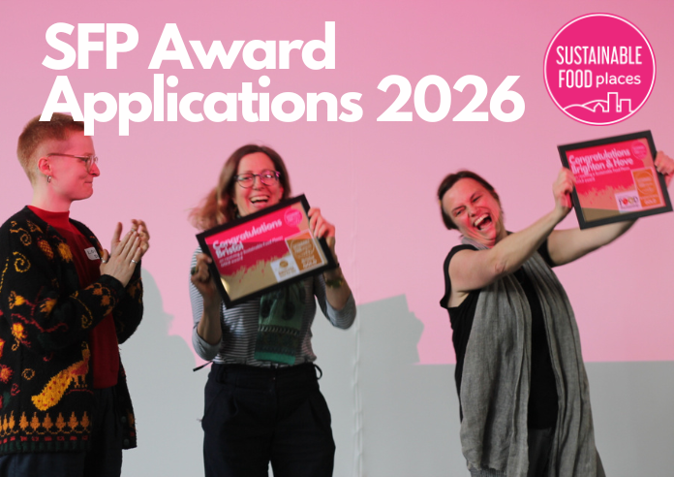
Before starting your application, please fully read this form as well as the following documents:
- SFP Awards: Guidance for applicants
- SFP Awards: Activity and Impact: SFP Awards - Activity and Impact.docx
Please also review our approach to Representation & Justice, including REDI for Change and the FAIR food framework. This approach has been co-designed with SFP members across the four nations of the UK. SFP expects that applications present a considered approach to diversity and representation.
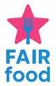
In 2026, a new FAIR food dimension has been applied across the SFP awards criteria to embed representation and justice across the SFP awards and to identify best practice. FAIR food recognises activities that facilitate, encourage, support and embed action on representation and justice in your food partnership and your food system work.
You will notice a greater emphasis on representation and justice across the SFP framework key issues and at all award levels: we have embedded representation and justice at the core of the Bronze, Silver and Gold awards.
In addition, you’ll notice FAIR food STAR criteria highlighted for each relevant Key Issue on this form. These describe additional, significant work on Representation and Justice, over and above the standard expectations for the Bronze or Silver Awards. These criteria are not compulsory, but where you do evidence exemplary work in these areas, this will be recognised and celebrated through SFP awarding a FAIR food STAR in addition to the Bronze or Silver Award.
Please do not alter the formatting of this form or redesign it and only return as a Word document not a PDF. This is essential for your application to pass the initial eligibility check.

SECTION 1: Information about your partnership and your place
Please complete the following (*= mandatory):
Name of your partnership*:
Name and contact details of person/people leading on this application*:
Geographic region which this award will represent*:
Award you are applying for*:

Please provide us with background information about your place (not scored)*: Advisory word limit: 400 words
This is to help the panel understand the context in which you are working. You may include (but not limited to): Population and demographic information, location/geography & economic and social challenges.
ANSWER:

SECTION 2: Local food activity and impact
Please read SFP Awards: Guidance for applicants before completing this section.
Please describe the activity and impact of local food work delivered in your place within the last three years against the relevant key issues (1-6) and action areas (A and B) below.
We advise that you keep answers to within 600 words for each action area (i.e. for each A and B under the key issues). Whilst you won’t be penalised for going over this limit, this will help the panel focus on your main achievements. For sections C, 250 words is the mandatory limit.
For Bronze and Silver awards, there are mandatory actions for some key issues. These are laid out in SFP Awards - Activity and Impact: SFP Awards - Activity and Impact.docx. This document also provides a broad benchmark for each award, rationale for SFP’s inclusion of each key issue, and example actions for each action area.
Only submit additional documents for food action plans and strategies related to Key Issue 1 mandatory criteria. All other additional documents will not be assessed. You may add links to online documents but always check the links and permissions as we will not be requesting changes from you after submission.
Key Issue 1 Mandatory Criteria Checklist
NB failure to provide Key Issue 1, Action area B mandatory criteria will result in rejection at the eligibility stage.
- Bronze applications require a one year action plan
- Silver applications require a three year action plan

- Have you submitted a current food action plan or food strategy with an action plan? Yes / No (delete as appropriate)

- How are you evidencing this action plan? (delete as appropriate)
- Attachment as a Word, PFF, Excel document?
- Link to a document?
- If a link place here as well under Key Issue 1
  - Action Plan link:

- Has the action plan less than 6 months to run?
- Yes / No (delete as appropriate)
- If less than 6 months to run, what is happening after the action plan expires? (100 words)

Key Issue 1: Taking a strategic and collaborative approach to good food governance and action
NB At Silver we require evidence that your food partnership has taken proactive steps to genuinely represent your place and its diverse communities in its work and activities
Action area A: Establish a broad, representative, and dynamic local food partnership
Action area B: Develop, deliver, and monitor a food strategy/action plan
C: Other information: Other activities and context (Please see Section 2 above for guidance) (Mandatory word limit: 250).

Key Issue 1 FAIR food STAR:
We will look for evidence that you have:
- Reflected on representation and justice e.g. regular REDI Review, FAIR food Action Plan.
- Demonstrated commitment to anti-racism and justice e.g. statement of commitment, code of conduct, proactive steps

Key Issue 2: Building public awareness, active food citizenship and a local good food movement

NB At Silver we require evidence that your food partnership has catalysed, influenced or delivered activity. Simply mapping activity is not sufficient: the ‘value added’ of the partnership must be demonstrated.
Action area A: Inspire and engage the public about good food
Action Area B: Foster food citizenship and a local good food movement
C: Other information: Other activities and context (Please see Section 2 above for guidance) (Mandatory word limit: 250).

Key Issue 2 FAIR food STAR:
We will look for evidence that you:
- Celebrate diverse food culture e.g. events, festivals, celebrations
- Embed representation and justice action e.g. FAIR food Action Plan, facilitating representation and engagement

Key Issue 3: Tackling food poverty and diet related ill-health and increasing access to affordable healthy food
NB At Silver we require evidence that your food partnership has catalysed, influenced or delivered activity. Simply mapping activity is not sufficient: the ‘value added’ of the partnership must be demonstrated.
Action area A: Tackle food poverty
Action Area B: Promote healthy eating
C: Other information: Other activities and context (Please see Section 2 above for guidance) (Mandatory word limit: 250).

Key Issue 3 FAIR food STAR:
We will look for evidence that you have:
- Embedded accountability in representation of marginalised communities e.g. engage with representative organisations and groups, establish new representative groups and panels, embedding lived experience

Key Issue 4: Creating a vibrant, prosperous, and diverse sustainable food economy
NB At Silver we require evidence that your food partnership has catalysed, influenced or delivered activity. Simply mapping activity is not sufficient: the ‘value added’ of the partnership must be demonstrated.
Action area A: Put good food enterprise at the heart of local economic development
Action Area B: Promote healthy, sustainable, and independent food businesses to consumers
C: Other information: Other activities and context (Please see Section 2 above for guidance) (Mandatory word limit: 250).

Key Issue 4 FAIR food STAR:
We will look for evidence that you:
- Facilitate and support representation of food producers e.g. establish working groups, representative forums, or engagement with existing associations/groups

Key Issue 5: Transforming catering and procurement and revitalising local and sustainable food supply chains
NB At Silver we require evidence that your food partnership has catalysed, influenced or delivered activity. Simply mapping activity is not sufficient: the ‘value added’ of the partnership must be demonstrated.

Action area A: Change policy and practice to put good food on people’s plates
Action Area B: Improving connections and collaboration across the local supply chain
C: Other information: Other activities and context (Please see Section 2 above for guidance) (Mandatory word limit: 250).

Key Issue 6: Tackling the climate and nature emergency through sustainable food & farming and an end to food waste
NB At Silver we require evidence that your food partnership has catalysed, influenced or delivered activity. Simply mapping activity is not sufficient: the ‘value added’ of the partnership must be demonstrated.
Action area A: Promote sustainable food production and consumption and resource efficiency
Action Area B: Reduce, redirect, and recycle food, packaging, and related waste
C: Other information: Other activities and context (Please see Section 2 above for guidance) (Mandatory word limit: 250).

