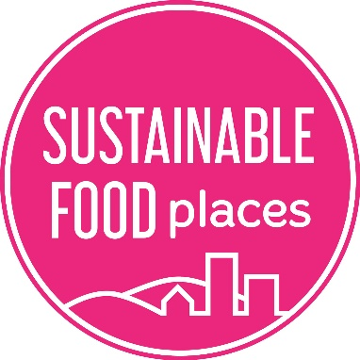

SUSTAINABLE FOOD PLACES
COUNTIES DEVELOPMENT GRANT ENGLAND
APPLICATION FORM
October 2020
Contents
Section 1: Grants Application Guidelines 3
1.1 Background 3
1.2 Grant offer 3
1.3 Who can apply? 4
1.4 Terms, conditions & reporting 4
1.5 Support with your application 4
1.6 Grant submissions 5
1.7 Sending us your application 5
1.8 How we will deal with your application 5
1.9 Timeline 5
Section 2: Grant Eligibility Form 6
1.10 Contact & eligibility information for applicants 6
1.11 Additional partnership employment information 7
Section 3: SFP COUNTIES DEVELOPMENT GRANT Application Form 8

Sustainable Food Places is funded by:
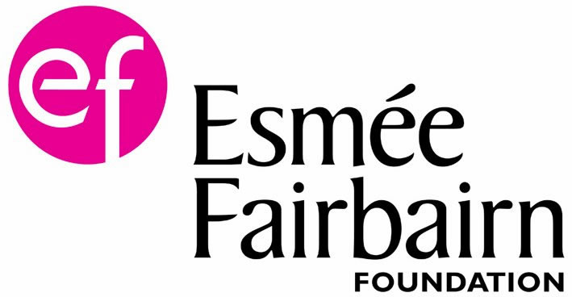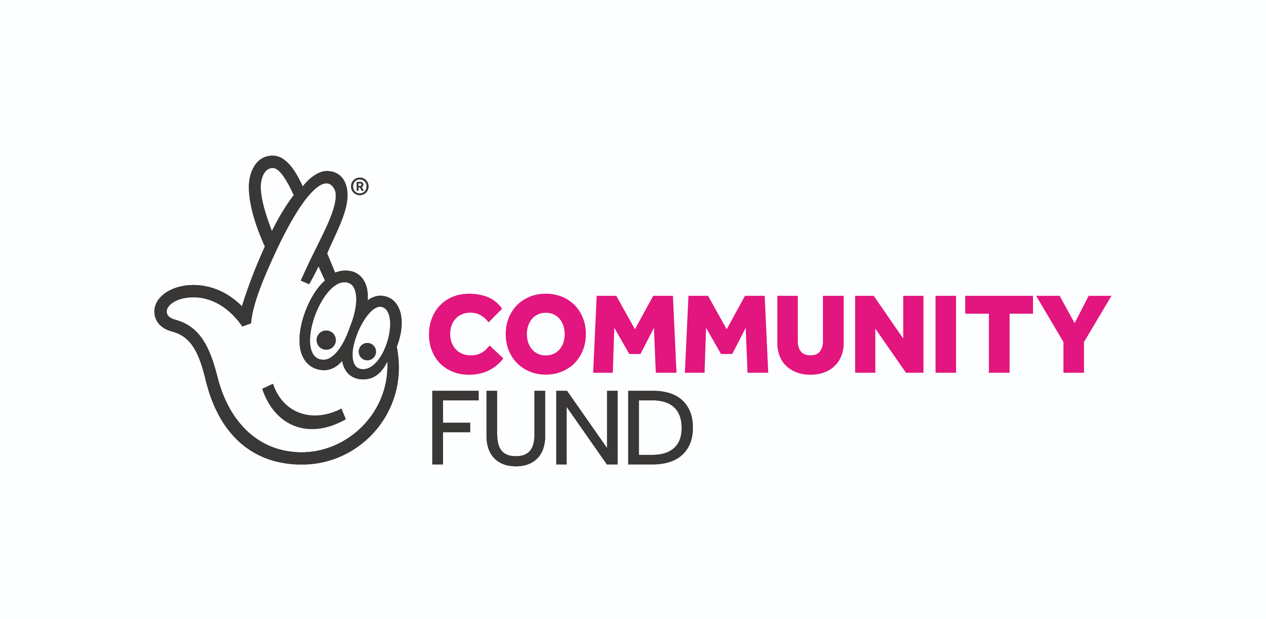

Section 1: Grants Application Guidelines

Background
Our ambition at Sustainable Food Places is to create a transition to a healthy, sustainable, and more equitable food system. We think that not only does this require strong national policy, but also collaborative action between policy makers, businesses, and society at the local level. We promote a systems approach that involves and connects key actors at all levels and across all parts of the food system. Since 2013 we have helped places across the UK to establish multi-sector food partnerships, develop local food strategies, and implement action across six key food issues.
Until now Sustainable Food Places has largely been a network of cities, but this is set to change. A key strand of our work going forward will focus on adapting and extending the model to new places and geographies across all four nations. Our initial focus in England will be on supporting the development of food partnerships in counties.
Our long-term aim is to support the development of a critical mass of counties acting collaboratively on sustainable food in England. To achieve this, we will work closely with county food partnerships to co-design our programme, membership, and award structure to ensure it is relevant and accessible. We recognise that the greatest learning happens when food partnerships can learn from each other. We will therefore convene a space and facilitate networking, knowledge and skill sharing for counties. We will also support counties to build and strengthen their food partnerships by offering guidance and advice as well as small grants.
As a first step we are offering short-term Development Grants to places that are in the early stages of creating a food partnership at a county level. Grant recipients will be expected to work closely with the SFP team during the period of their grant as we test out approaches and models for county working. This will include online workshops with other grant recipients facilitated by the SFP team. The Development Grants are to be spent over a 6-month period, at the end of which it is expected that places will be on track to apply for SFP membership if they have not yet joined the network. For information on membership requirements see our membership page.
In summer 2021, these Development Grants will be followed by an opportunity to apply for County Food Partnership Coordinator Grants. These will be £10k per annum grants for 2 years and will require equal match funding. All county food partnerships that have either achieved SFP membership or are in receipt of a Development Grant and on track to achieve SFP membership will be eligible to apply, though the number of Coordinator Grants will be limited so not all applicants will be successful.

Grant offer
Counties Development Grants (England): We are offering up to 4 grants of up to £5,000 each to be spent within 6 months (Jan 2021– June 2021). If you can show match funding or in-kind contributions to support your proposed initiative it will add to the strength of your application, but this is not a requirement.
Most of the funds should be for person time, but it is also possible to include some third-party costs (e.g. facilitator fees, travel, room hire etc.). Note: If you have secured match funding to support this work, we ask you to provide a commitment letter demonstrating this as part of your application.

Who can apply?
Applications are open to food partnerships or emerging food partnerships operating across a county in England. This will include both County Council areas and County Unitary Authority areas. For a full list of eligible areas see counties listed here. Food partnerships operating at solely a district or town scale will not be funded.
Food partnerships must either:
- Have not yet joined Sustainable Food Places, OR
- Have recently started to extend their geographic remit from city to county
Partnerships must have a letter of support from their local authority which will need to be submitted alongside their application. (This should be from the County Council or County Unitary Authority). It is expected that local authorities will demonstrate an active involvement with the establishment and work of the food partnership. This might include a local authority officer attending SFP workshops.
We recommend all applicants spend time on the Sustainable Food Places website and become familiar with SFP aims, key issues and awards framework for measuring progress. In particular you may find the Sustainable Food Places Toolkit helpful when thinking about the early stages of your partnership.
If your food partnership is not yet legally constituted then you must apply jointly with a host organisation. Details of the host organisation must be provided with this application and they must manage all legal and financial requirements for any contracts related to this grant. Host organisations can be statutory (local authority) or third sector organisations. Grants will not be paid to individuals or businesses.

Terms, conditions & reporting
The Grant Offer Letter will detail the full terms and conditions we agree with you. This will include a requirement to complete two quarterly progress reports and other details relating to the management of the grant.
To fulfil our due diligence responsibilities on behalf of our funders and programme partners, we must ensure that grant funding is being invested directly into staff capacity (new or existing) that is specifically allocated to the delivery of SFP partnership and programme work as specified in successful grant applications and subsequent grant agreements.
In cases where the work is being delivered by Council staff, funding from us must be used for additional, not existing, activity. We cannot fund anything that is the legal (statutory) responsibility of local and national government or public sector.
Successful applicants will be asked confirm in writing that the grant will be used as outlined in your application and to provide the name and job title of the person who will deliver this work, as well as the average number of days per week they will allocate to this work through the period of the grant funding.
Payment will be made in two instalments, with 80% in advance and 20% on completion of the work and submission of a satisfactory final report. The first instalment will be in January 2021 at the earliest and dependent on receipt of a signed Grant Agreement and invoice.

Support with your application
We recommend that before writing your application you arrange a call with us to discuss your ideas / plans and go through any questions you may have. Please email sarah@foodmatters.org to set up your call.

Grant submissions
Applications must be submitted by 9am on 7th December 2020. Applicants will be informed of the grants panel decision the week beginning 21st December 2020. Successful applicants will ideally start work soon after notification of their grant and must have begun work by 31st January 2021. You will find the application form below. Please keep to the word limit for each question and DO NOT SUBMIT ADDITIONAL MATERIALS, as they will not be considered.

Sending us your application
Use the form below to apply for a grant. Fill in the relevant sections and return this document to us. The first section is contact and eligibility information. The second section is for the detail of your application for a SFP Development Grant.
Email your application to sfcgrants@soilassociation.org by 9am Monday 7th Dec 2020.

How we will deal with your application
You will receive an email from us confirming that we have received your application. Applications are assessed by the Sustainable Food Places Programme Management Board and all decisions are final. We may ask you for further information. We aim to deal with all applications in a friendly and efficient fashion. If we fall short of these aims, please let us know. We can provide limited feedback upon request to unsuccessful applicants.

Timeline
26 October 2020 Applications open
9am 7 December 2020 Deadline for applications
w/c 14 December 2020 Final decision by SFP Grants Panel
w/c 21 December 2020 Comms to successful & unsuccessful applicants
January 2021 Funded Development work begins
By 31 January 2021 Agreements signed & invoices sent
Dates for the progress reports will be set once the agreements have been signed off.
Contact: If you have questions relating to the submission of your application please email sarah@foodmatters.org

Section 2: Grant Eligibility Form

2.1 Contact & eligibility information for applicants
Name of food partnership (if already set up)
County covered by food partnership (Note: the food partnership should cover the whole county, not just one district or town within it).
SFP Network Member | Yes / No
If yes, have you extended your geographic remit from city to county wide? Please give details.
Name of person writing this bid
Email
Phone number
Name of intended host organisation for the development work (can be the local food partnership if legally constituted)
Host organisation contact name
Host organisation contact email
Host organisation contact phone
Host organisation legal status (CIC, Local Authority, Charity etc.)
Who will manage the work?
Has any match funding been secured? (this is not a requirement). | Yes / No
How much match funding has been committed to? (if any)
Who / what is the source of this funding?
Have you submitted a letter of commitment from your match funding source? | Yes / No
Have any in-kind contributions been secured? (please give details)

Have you submitted a letter of support from your local authority (County Council, County Unitary Authority)? | Yes / No

2.2 Additional partnership employment information
In no more than a few sentences, set out:
a. What paid capacity does your county food partnership currently have including current FTE and any end date to that employment?

b. Any funding for staff time be invested directly into staff capacity (new or existing) that is specifically allocated to the delivery of SFP development work outlined in this application. Please tell us who is likely to carry out the work and the average number of days per week they will allocate to its delivery through the period of the grant (e.g. 1 day per week for 6 months)?

Section 3: SFP COUNTIES DEVELOPMENT GRANT Application Form
Please answer the questions below:
Q1. What have you achieved so far?
Please provide us with a brief overview of any work undertaken to date to build your county food partnership – e.g. meetings held, background research, discussions with local authorities, consultations, surveys, or events bringing stakeholders together. (maximum 300 words)

Q2. Who has been involved so far? Please list stakeholders that have been engaged and the nature of that engagement (e.g. attends regular meetings / working group, one-off discussion, attended event etc.)

Stakeholder organisation | Job title | Nature of involvement

Q3. How do you know that there is a broad interest and ambition to cover the 6 SFP Key Issues in your partnership? (maximum 150 words)
If you have agreed a vision statement, please include it here.
NOTE: If you are able to submit letters of support from key stakeholders to demonstrate the breadth of interest, this will strengthen your application.

Q4. What are your priorities for the next 6 months? (maximum 150 words)

Q5. What do you plan to spend the money on? If this is person time give details of the activities that will be undertaken. (maximum 150 words)

Q5 What are the key objectives, actions and targets you hope to deliver over the next 6 months? (max 250 words or you can use a table like the example below)

Objectives | Action | Target
e.g. To build broad engagement from stakeholders | e.g. Meet 1:1 with key stakeholders | e.g. 10 key stakeholders’ meetings held

Q6. Budget
Please complete Table 1, Table 2 (if appropriate) and Table 3 below. If this grant is match funded it should be for person time. Some third-party costs can be included in the overall budget e.g. resources, publicity, facilitation.
Table 1: SFP County Development Grant Funding.
Please fill in all shaded sections. If zero please state
 | Requested Funding Up to £5,000 | Match Funding | Total
SFP County Development Work – person time plus on-costs*
Source | SFP Grant
*Inclusive of Employers National Insurance and pension contributions
Table 2: SFP County Development Grant 3rd party costs*
If you are including 3rd party costs, please provide a headline breakdown below
Item | Unit Cost | Total
*Resources, venue hire, facilitation costs etc.

Table 3: SFP County Development Work Start / Finish Dates. Please fill in all shaded sections
Proposed SFP Grant Funded County Development Work Start Date*
Proposed SFP Grant Funded County Development Work End Date**
* Must be by 31st January 2021
** Must be completed by 30th June 2021.

